Sharing Email Template for Travel Companies ✅

Email Template Guide

- Copy and paste the image and email text
- Customise all the selected fields with your own content and information

Tips to make your template perfect

- If you would like image to be branded, please reach out to us and we can pop your logo on!
- Feel free to add a reminder to people to ‘allow’ notifications upon login

Subject line: Important Information about your trip 🚀

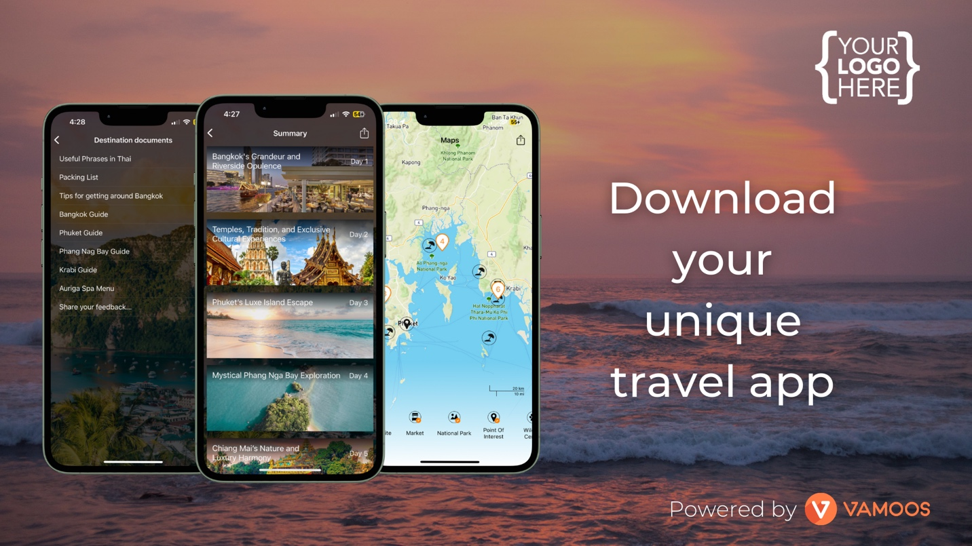

Hi [CLIENT NAME],
The countdown to your trip has begun!
We've created an app for you to access all your unique trip information including: itinerary, essential documents, maps, live flight information, local recommendations and much more.
It's free and easy to download, just follow these steps:

How to Download
1 - Download the Vamoos App FREE on the iOS App Store or Google Play Store
2 - When you open the app you'll be asked for 'User ID' and then a 'Passcode' please enter:

USER ID: [YOUR USER ID HERE]
PASSCODE: [YOUR PASSCODE HERE]

It's as easy as that, now all the information you need to enjoy your trip is at your fingertips.
Just follow the links below or scan the QR code to download Vamoos and get started!

Have a great trip!

Yours sincerely,
[YOUR NAME]

Download our App Here!


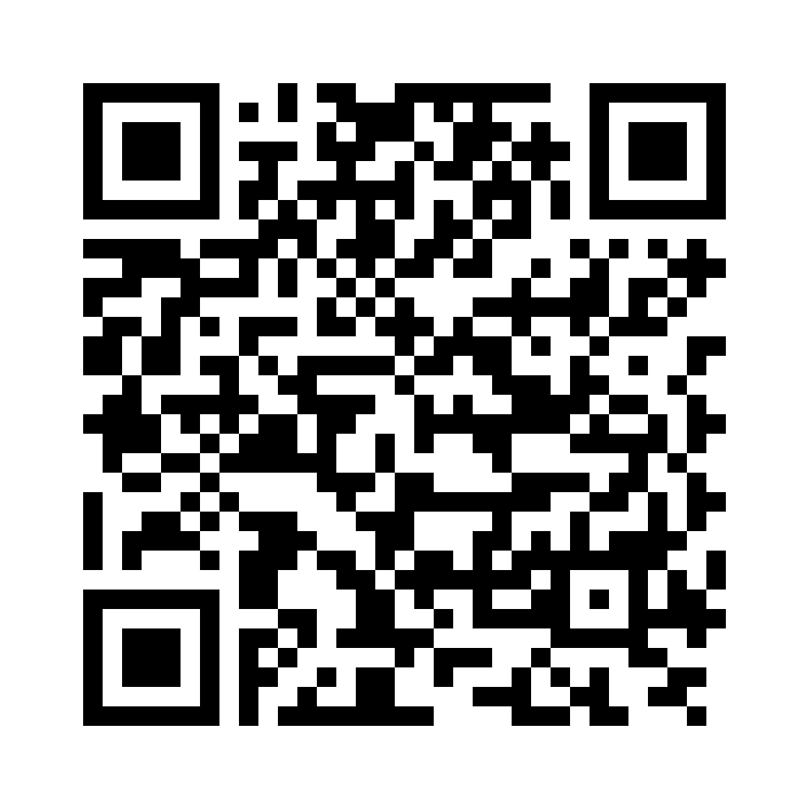
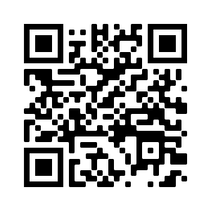

Click to unsubscribe

