Sharing Email Template for Events ✅

Email Template Guide

- Copy and paste the image and email text
- Customise all the selected fields with your own content and information

Tips to make your template perfect

- If you would like this branded, please reach out to us and we can pop your logo on!
- Feel free to add a reminder to people to ‘allow’ notifications upon login

Subject line: We can’t wait to welcome you! 🍾

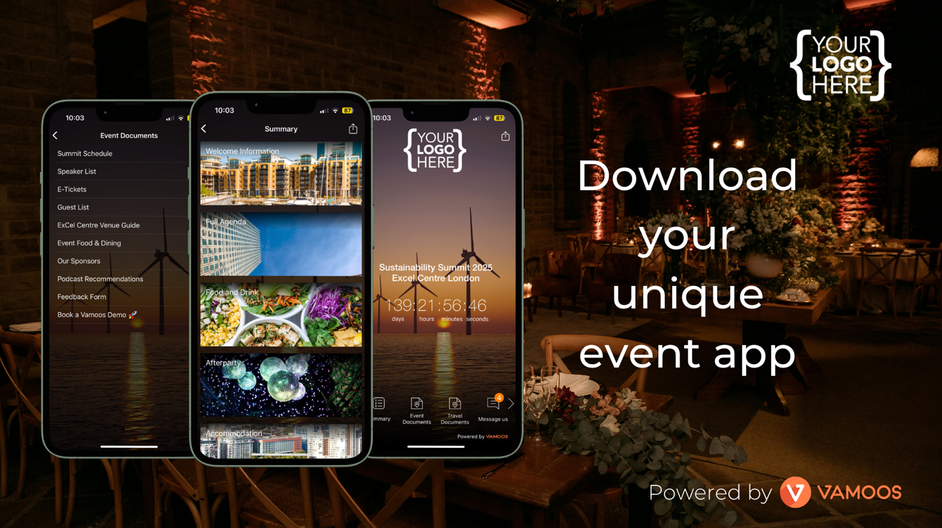

Hi [CLIENT NAME],
The countdown to [Insert Event Name] has begun!
We've created an app for you to access all your event information including: [Agenda, Speaker information, Sponsors, Useful Documents, Venue Map, etc] and much more.
It's free and easy to download, just follow these steps:

How to Download
1 - Download the Vamoos App FREE on the iOS App Store or Google Play Store
2 - When you open the app you'll be asked for a 'User ID' and then a ‘Passcode’ please enter:

USER ID: [YOUR USER ID HERE]
PASSCODE: [YOUR PASSCODE HERE]

It's as easy as that, now all the information you need to enjoy [Insert Event Name] is at your fingertips.
Just follow the links below or scan the QR code to download Vamoos and get started!

Have a great event!

Yours sincerely,
[YOUR NAME]

Download our App Here!
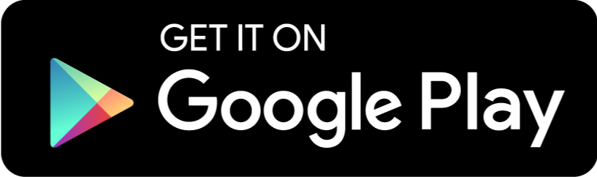

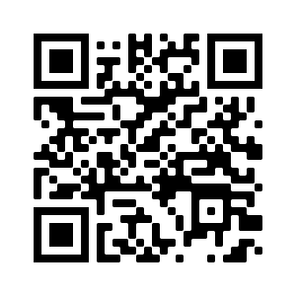
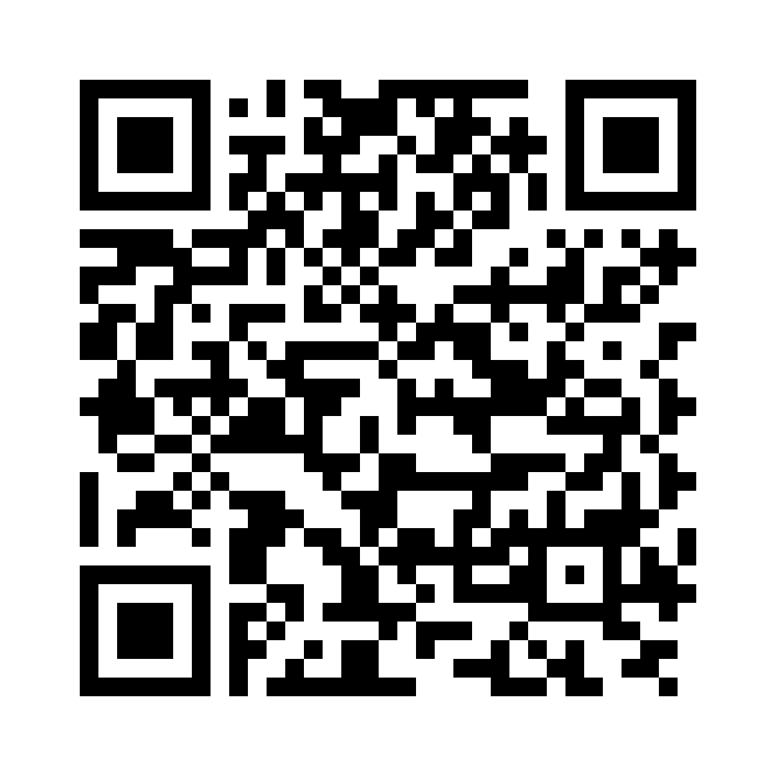

Click to unsubscribe

