Sharing Email Template for Hotels and Accommodations ✅

Email Template Guide

- Copy and paste the image and email text
- Customise all the selected fields with your own content and information

Tips to make your template perfect

- If you would like this branded, please reach out to us and we can pop your logo on!
- Feel free to add a reminder to people to ‘allow’ notifications upon login
- If you have made email login mandatory, you may want to mention that guests will need to insert their email
- You can also pop in a section about adding their check-in and check-out dates!

Subject line: Important Information about your stay 🏠

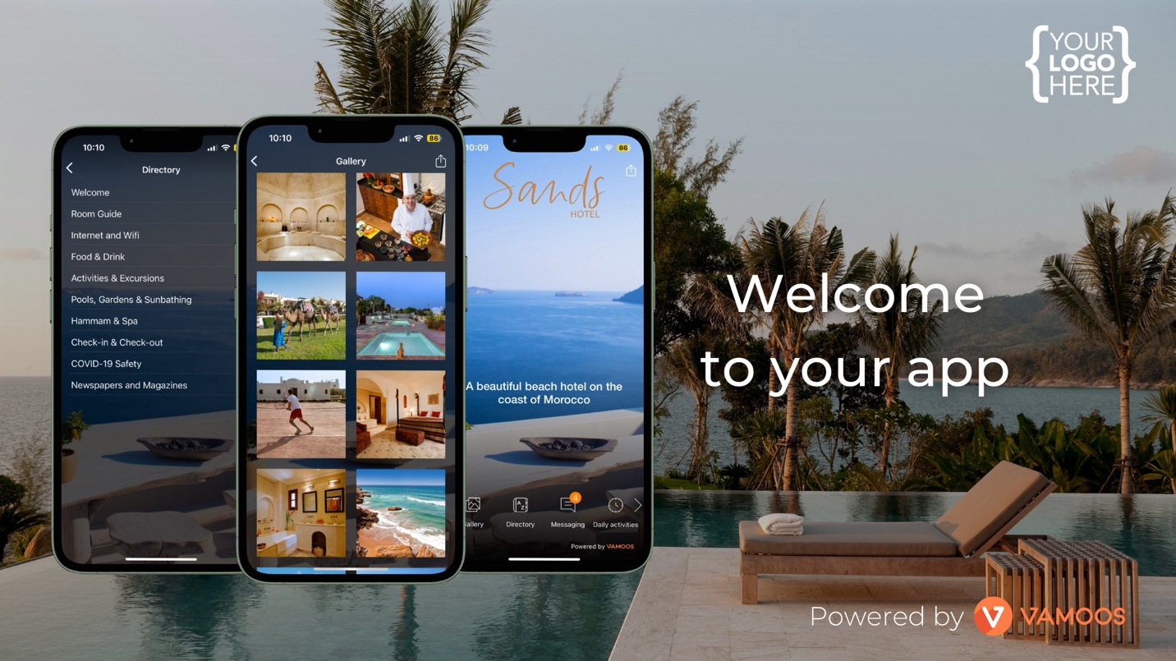

Hi [CLIENT NAME],
The countdown to your holiday has begun!
We've created an app for you to access all your unique property information including: property directory, essential documents, maps, daily activities, local recommendations and much more.
It's free and easy to download, just follow these steps:

How to Download
1 - Download the Vamoos App FREE on the iOS App Store or Google Play Store
2 - When you open the app you'll be asked for a 'User ID', please enter:

USER ID: [YOUR USER ID HERE]

It's as easy as that, now all the information you need to enjoy your stay is at your fingertips.
Just follow the links below or scan the QR code to download Vamoos and get started!

Have a great trip!

Yours sincerely,
[YOUR NAME]

Download our App Here!
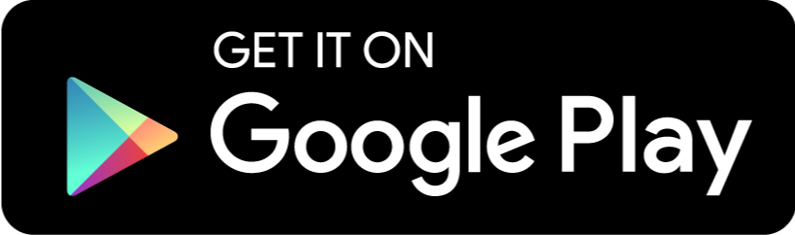

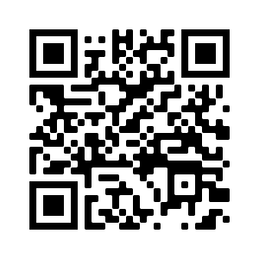
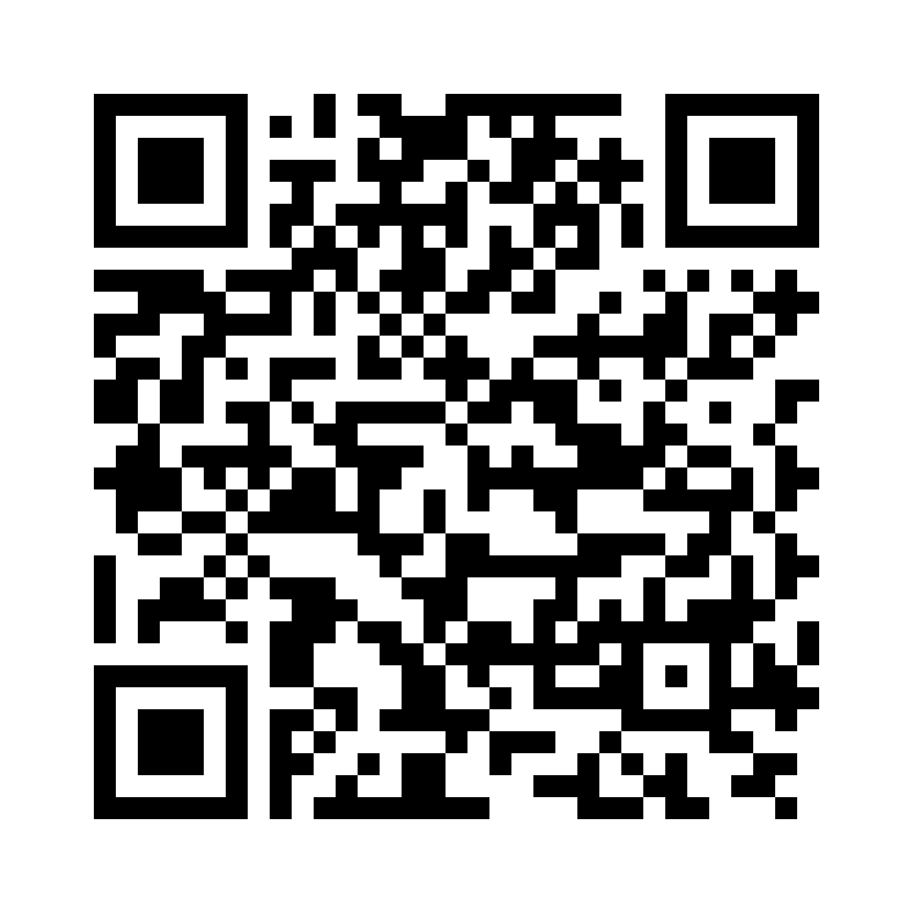

Click to unsubscribe

